

EE366L/CE366L: Introduction to Robotics Lab

Dr Basit Memon

Muhammad Hassan Shah

Lab 6: Inverse Kinematics

Sadaf Shaikh and Mohammad Hasan Tariq

March 9th 2022

Task 6.1

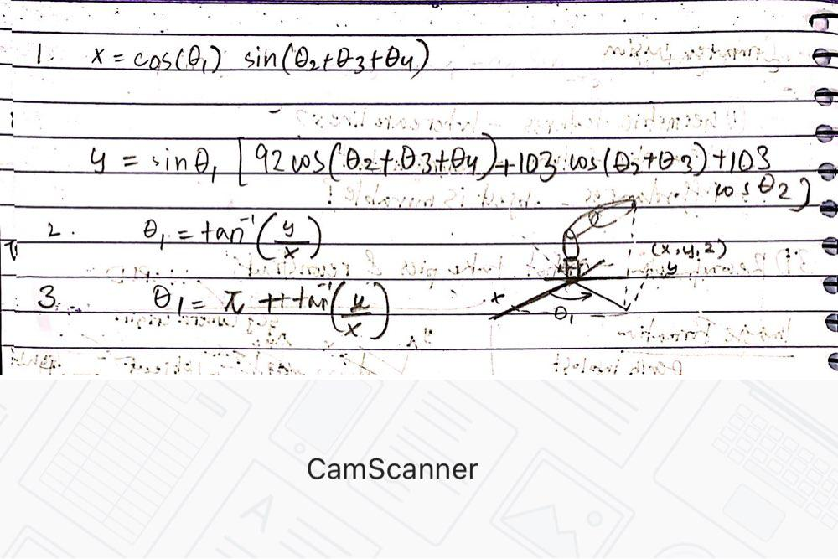

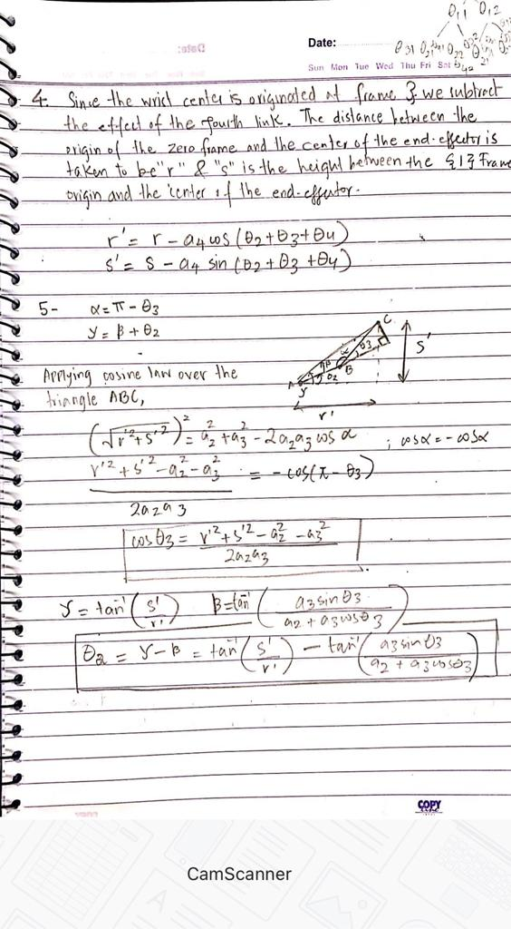v

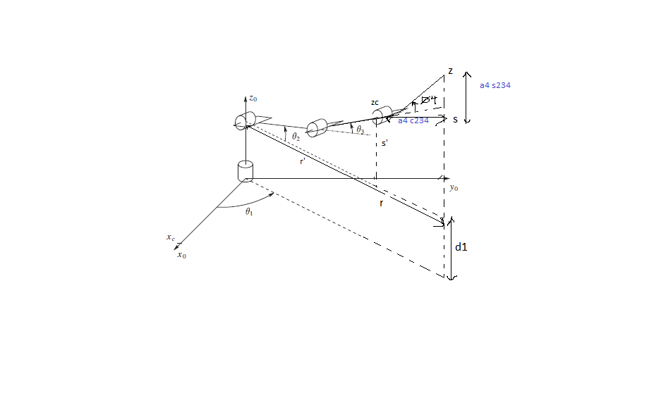

Figure 1: Determination of joint angles using Geometric Approach

6 –

There are four total solutions. For each $θ_{1}$, we have two ${ θ}_{2}$, ${ θ}_{3}$ pairs.

7 –

${ θ}_{4}$ = $∅$- ${ θ}_{2}$- ${ θ}_{3}$

Task 6.2

function solutions = findJointAngles(x,y,z,phi)

% x, y and z are the coordinates of the center of teh end-effector that is

% the 4th frame

theta_1_1 = atan2(y,x);

theta_1_2 = - pi + atan2(y,x);

d_1 = 141;

a_4 = 92;

a_3 = 103;

a_2 = 103;

r = sqrt(x^2 + y^2);

s = z - d_1;

r_2 = r - a_4*cos(phi);

s_2 = s - a_4*sin(phi);

alpha = acos((-(r_2^2 + s_2^2) + a_2^2 + a_3^2)/(2*a_2*a_3));

temp = (a_2^2 + s_2^2 + r_2^2 - a_3^2)/ (2 * a_2 * sqrt(s_2^2 + r_2^2));

beta = atan2(sqrt(1 - temp^2),temp);

gamma = atan2(s_2,r_2);

theta_2_1 = gamma - beta;

theta_2_2 = gamma + beta;

theta_3_1 = pi - alpha;

theta_3_2 = - pi + alpha;

theta_4_1 = phi - theta_3_1 - theta_2_1;

theta_4_2 = phi - theta_3_2 - theta_2_2;

solutions = [theta_1_1 theta_2_1 theta_3_1 theta_4_1;

theta_1_1 theta_2_2 theta_3_2 theta_4_2;

theta_1_2 pi-theta_2_1 -theta_3_1 -theta_4_1;

theta_1_2 pi-theta_2_2 -theta_3_2 -theta_4_2];

end

Task 6.3

Yes. We used the configuration (x,y,z, phi) = (120,120,250,1)

Task 6.4

|  |  |  |  |
| --- | --- | --- | --- |
| Model Coordinates (units) | Actual Coordinates (mm) | Absolute Error(mm) | Euclidean error (mm) |
| (50,-20,180,0) | (61-20,180,0) | (11,0,0,0) | 11 |
| (103,-140,193,0) | (119,-146,180,0) | (16,6,13,0) | 21.471 |
| (100.27,-136.2925,180.2773,0) | (119,-152,172,0) | (18.73,15.7075,8.2773,0) | 25.81 |

Mean error is calculated as:

$$Error= \frac{11+21.471+25.81}{3}=∓19.43 mm$$

Task 6.5

